Website Showcase Submission

**Team Members:**

Anna Le

Conner Giles

Paolo Colmenares

Ashish Goolla

Evan Rocha

**Screenshot of Homepage:**

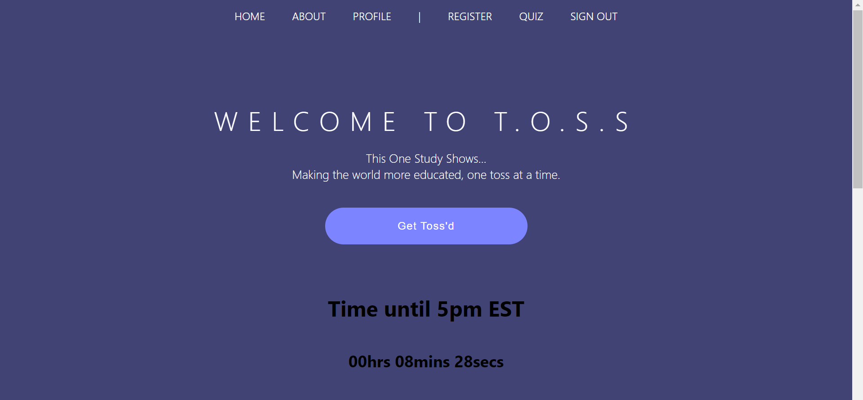

**3 gifs showing off website:**

(3 gifs also submitted individually on Canvas)

Summer2020_5_TOSS_1.gif



Summer2020_5_TOSS_2.gif



Summer2020_5_TOSS_3.gif



**List of Features:**

* Allows users to create an account with username/password. Has log-in and register pages.
* Profile page featuring profile picture, username, MFT scores table
* Moral Standings Test and table displaying 5 key values
* About page, describing the purpose of the project.
* Allows users to submit a 500 character response to TOSS prompts along with a credible source about the topic
* Allows users to view other users responses on a prompt after 24-hours
* TOSS clock countdown on home page